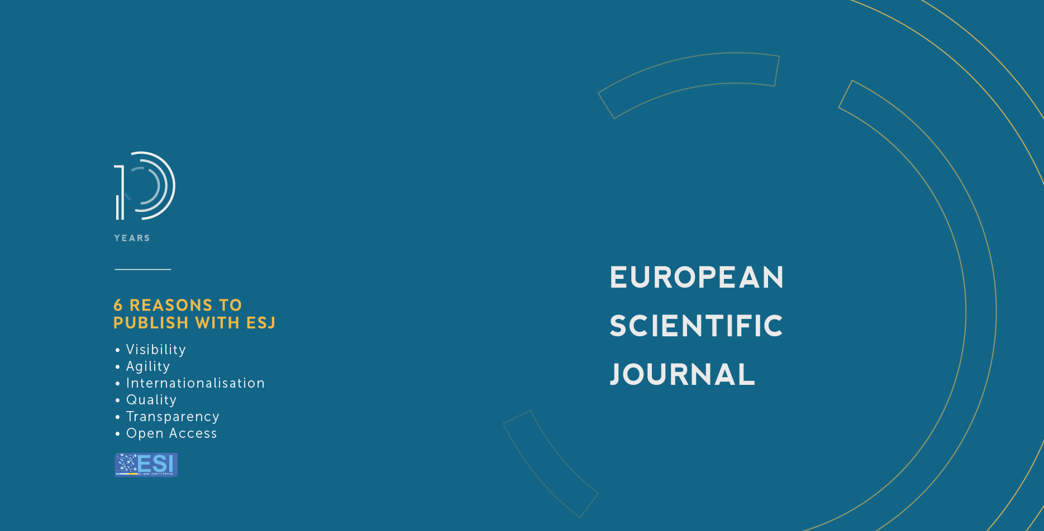

Paper: “Comparative Clinical Trial of Fluoridated Varnishes with Calcium Compounds to Prevent and Reverse Incipient Carious Lesions in School Children”

Corresponding Author: Maria Lilia Juarez-Lopez

Doi: 10.19044/esj.2020.v16n18p93

Peer review:

Reviewer 1: Monica Monea, University of Medicine and Pharmacy of Tirgu Mures, Romania

Reviewer 2: Jorge Luis Soto Balderas, Benemérita Universidad Autónoma de Puebla, México

Reviewer 3: Juan Pablo Loyola-Rodriguez, UPAEP/Mexico

Published: 30.06.2020

ESJ Manuscript Evaluation Form 2020

This form is designed to summarize the manuscript peer review that you have completed and to ensure that you have considered all appropriate criteria in your review. Your review should provide a clear statement, to the authors and editors, of the modifications necessary before the paper can be published or the specific reasons for rejection.

Please respond within the appointed time so that we can give the authors timely responses and feedback.

NOTE: ESJ promotes peer review procedure based on scientific validity and technical quality of the paper (not perceived the impact). You are also not required to do proofreading of the paper. It could be recommended as part of the revision.
ESJ editorial office would like to express its special gratitude for your time and efforts. Our editorial team is a substantial reason that stands ESJ out from the crowd!

Reviewer Name: Monica Monea
University/Country:``George Emil Palade``University of Medicine, Pharmacy, Science and Technology Tirgu Mures/ Romania
Date Manuscript Received: 30.04.2020 | Date Review Report Submitted: 02.05.2020
Manuscript Title:
Fluoridated varnishes with calcium compounds for incipient carious lesions in school children. Clinical trial

ESJ Manuscript Number: 0542/20
You agree your name is revealed to the author of the paper: Yes
You approve, your name as a reviewer of this paper, is available in the “review history” of the paper: Yes
You approve, this review report is available in the “review history” of the paper: Yes

Evaluation Criteria:
Please give each evaluation item a numeric rating on a 5-point scale, along with a thorough explanation for each point rating.
Questions | Rating Result  [Poor] 1-5 [Excellent]
1. The title is clear and it is adequate to the content of the article. | 5
The title is adequate, concise and clear and indicates in a synthetic manner the topic of the research work. In a few words, all important clues are offered.

2. The abstract clearly presents objects, methods and results. | 5
By reading the abstract it is easy to understand the purpose, clinical steps and statistical evaluation of the collected data. The conclusions are credible, according to the information presented by the authors in the abstract.

3. There are few grammatical errors and spelling mistakes in this article. | 5
I could find no grammatical errors in the manuscript

4. The study methods are explained clearly. | 5
The Materials and Methods contain a very well explained research methodology, including the ethical standards applied by the research protocol. The study groups and control groups are clearly described, the prevalence of dental caries is measured according to the tests agreed by international researchers and the statistical analysis is appropriate.
5. The body of the paper is clear and does not contain errors. | 5
The body of the paper is scientifically correct, easy to read, clear and presents very well the actual knowledge upon treatment of early lesions, proper treatment and offers a better understanding of the preventive measures that might enhance the reduction of caries incidence in children.

6. The conclusions or summary are accurate and supported by the content. | 5
The conclusions of this study are fully supported by the research conducted by the authors.

7. The references are comprehensive and appropriate. | 5
All references are related with the topic of the paper and there is mostly new data available in the scientific literature.

Overall Recommendation (mark an X with your recommendation)：
Accepted, no revision needed | X
Accepted, minor revision needed
Return for major revision and resubmission
Reject

Comments and Suggestions to the Author(s):
Dear authors,
Congratulation for your work, it was a pleasure to read your paper and I felt that we speak the same language when it comes to dental caries and its most appropriate preventive measures.

Comments and Suggestions to the Editors Only:
Dear Editor,
I consider that this manuscript can be published without revision, it is well documented and scientifically sound. Furthermore, the area of dental caries prevention in children is a matter of intense debate in the scientific literature and this article might be of interest for many researchers.

ESJ Manuscript Evaluation Form 2020
This form is designed to summarize the manuscript peer review that you have completed and to ensure that you have considered all appropriate criteria in your review. Your review should provide a clear statement, to the authors and editors, of the modifications necessary before the paper can be published or the specific reasons for rejection.

Please respond within the appointed time so that we can give the authors timely responses and feedback.

NOTE: ESJ promotes peer review procedure based on scientific validity and technical quality of the paper (not perceived the impact). You are also not required to do proofreading of the paper. It could be recommended as part of the revision.
ESJ editorial office would like to express its special gratitude for your time and efforts. Our editorial team is a substantial reason that stands ESJ out from the crowd!

Reviewer Name: Jorge Luis Soto Balderas
University/Country: Benemérita Universidad Autónoma de Puebla, México
Date Manuscript Received: May 11 | Date Review Report Submitted: May 14
Manuscript Title: Fluoridated varnishes with calcium compounds for incipient carious lesions in school children. Clinical trial
ESJ Manuscript Number:
You agree your name is revealed to the author of the paper: Yes
You approve, your name as a reviewer of this paper, is available in the “review history” of the paper: Yes
You approve, this review report is available in the “review history” of the paper: Yes

Evaluation Criteria:
Please give each evaluation item a numeric rating on a 5-point scale, along with a thorough explanation for each point rating.
Questions | Rating Result  [Poor] 1-5 [Excellent]
1. The title is clear and it is adequate to the content of the article. | 4
Yes. Even tough it could have been better to be added that it is a comparative study.
2. The abstract clearly presents objects, methods and results. | 5
Yes, it is clear and summarizes the content of this study.
3. There are few grammatical errors and spelling mistakes in this article. | 4
Regarding the drafting, I suggest to the authors, to change in the conclusion the word "seemed to provide ...", for "showed a better ..." This way it gives an idea that the results are not clear
4. The study methods are explained clearly. | 5
Yes, they are clear and it is appropriate that all aspects were considered.
5. The body of the paper is clear and does not contain errors. | 4
It is clear, complete and no errors were found, except the one already mentioned in number 3
6. The conclusions or summary are accurate and supported by the content. | 4
In general, it is only necessary to take note in the conclusions on what is indicated in number 3
7. The references are comprehensive and appropriate. | 5
The number of references is adequate and appropriate.

Overall Recommendation (mark an X with your recommendation)：
Accepted, no revision needed
Accepted, minor revision needed | x
Return for major revision and resubmission
Reject

ESJ Manuscript Evaluation Form 2020

This form is designed to summarize the manuscript peer review that you have completed and to ensure that you have considered all appropriate criteria in your review. Your review should provide a clear statement, to the authors and editors, of the modifications necessary before the paper can be published or the specific reasons for rejection.

Please respond within the appointed time so that we can give the authors timely responses and feedback.

NOTE: ESJ promotes peer review procedure based on scientific validity and technical quality of the paper (not perceived the impact). You are also not required to do proofreading of the paper. It could be recommended as part of the revision.
ESJ editorial office would like to express its special gratitude for your time and efforts. Our editorial team is a substantial reason that stands ESJ out from the crowd!

ReviewerName: Juan Pablo Loyola-Rodriguez | Email:
University/Country:UPAEP/Mexico
Date Manuscript Received:05/12/2020 | Date Review Report Submitted: 05/29/2020
Manuscript Title: Fluoridated varnishes with calcium compounds for incipient carious lesions in school children. Clinical trial.
ESJ Manuscript Number: 42.05.2020
You agree your name is revealed to the author of the paper: Yes/No
You approve, your name as a reviewer of this paper, is available in the “review history” of the paper:Yes/No
You approve, this review report is available in the “review history” of the paper:Yes/No

Evaluation Criteria:
Please give each evaluation item a numeric rating on a 5-point scale, along with a thorough explanation for each point rating.
Questions | Rating Result  [Poor] 1-5 [Excellent]
1. The title is clear and it is adequate to the content of the article.
(Please insert your comments)
Fluoridated varnishes with calcium compounds for incipient carious lesions in school children. Clinical trial-

The title is not clearly written since the author failed to mention the main aim to prevent and reverse incipient carious lesions

2. The abstract clearly presents objects, methods and results.
(Please insert your comments)
This sentence is too short “CPP-ACP/NaFshowed difference with control. P=0.001”.
It should de modified for clartity

3. There are few grammatical errors and spelling mistakes in this article.
(Please insert your comments)
The manuscript shows some grammatical error and typos throughout the manuscript- Editing will be necessary.

4. The study methods are explained clearly.
(Please insert your comments)
The main idea is interesting especially when working in developing economies such as Mexico. However, there are some issues that are absent in this research work. The age of study groups was 7-9 year old children that have two dentitions (primary and mixed), it is not clear if they are talking about primary or permanent teeth. This is very important since the enamel structure of this tooth is quite different.

On the other hand, I am wondering why they did no apply a varnish in the right side (upper and lower maxilla) and the other varnish in the left side. There is no better control that the same mounth of the patient.

The methodology is not clear, fig. 2 mention about dentin caries, dental decay that include dentin tissue in not incipient. Besides there some typos in foot note DCL (dental caries lesions) but in the upper part of the figure is described as CCL.

In table 1, row need to be align.

In table 2. The baseline subheading is not clear, what they want to express with that?

Fig. 1 is unnecessary the information is in the methods and results sections.

5. The body of the paper is clear and does not contain errors.
(Please insert your comments)
The manuscript shows some grammatical error and typos throughout the manuscript- Editing will be necessary.

6. The conclusions or summary are accurate and supported by the content.
(Please insert your comments)
The statement “reverse incipient carious lesions” is not supported by the data. I recommend to consider to modified this term. Perhaps “Demineralization” could be a better term.
7. The references are comprehensive and appropriate.
(Please insert your comments)
Yes, the references are ok.

Overall Recommendation(mark an X with your recommendation)：
Accepted, no revision needed
Accepted, minor revision needed
Return for major revision and resubmission | X
Reject

Comments and Suggestions to the Author(s):
To analyze the methodoly of the study. I believe that splitting the data into primary and permanent tooth should analize the data. Delete the information about dentine lesions (fig. 2) is not in the aim of the manuscript. The are some grammatical error and typos, the manuscript need some editing.

Comments and Suggestions to the Editors Only:
None

